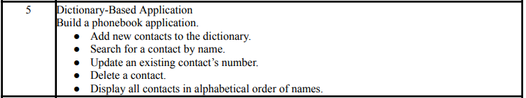
COMMAND:
'''Dictionary-Based Application
Build a phonebook application.
● Add new contacts to the dictionary.
● Search for a contact by name.
● Update an existing contact’s number.
● Delete a contact.
● Display all contacts in alphabetical order of names.'''

# Phonebook Application

phonebook = {} # Empty dictionary to store contacts

def add_contact():
name = input("Enter name: ").strip().title()
if name in phonebook:
print(f"{name} already exists in the phonebook.")
else:
number = input("Enter phone number: ").strip()
phonebook[name] = number
print(f"{name} added successfully.")

def search_contact():
name = input("Enter name to search: ").strip().title()
if name in phonebook:
print(f"{name}'s number is {phonebook[name]}")
else:
print(f"{name} not found in the phonebook.")

def update_contact():
name = input("Enter name to update: ").strip().title()
if name in phonebook:
number = input(f"Enter new phone number for {name}: ").strip()
phonebook[name] = number
print(f"{name}'s number updated successfully.")
else:
print(f"{name} not found in the phonebook.")

def delete_contact():
name = input("Enter name to delete: ").strip().title()
if name in phonebook:
del phonebook[name]
print(f"{name} deleted successfully.")
else:
print(f"{name} not found in the phonebook.")

def display_contacts():
if not phonebook:
print("Phonebook is empty.")
else:
print("\nContacts in alphabetical order:")
for name in sorted(phonebook):
print(f"{name}: {phonebook[name]}")

# Menu Loop
while True:
print("\n--- Phonebook Menu ---")
print("1. Add Contact")
print("2. Search Contact")
print("3. Update Contact")
print("4. Delete Contact")
print("5. Display All Contacts")
print("6. Exit")

choice = input("Enter your choice (1-6): ").strip()

if choice == '1':
add_contact()
elif choice == '2':
search_contact()
elif choice == '3':
update_contact()
elif choice == '4':
delete_contact()
elif choice == '5':
display_contacts()
elif choice == '6':
print("Exiting Phonebook. Goodbye!")
break
else:
print("Invalid choice! Please enter a number from 1 to 6.")

OUTPUT:
